**First Neural Network**

**Input: 6 features of Signal (without noise, with noise)**

**Number of datapoint: 2100**

**Number of Segmentation: 210 (for each 10 datapoint)**

**Number of classes: 3**

**Neural Network: MLP Classifier**

**Output: confusion matrix + Plot**

**First Step**

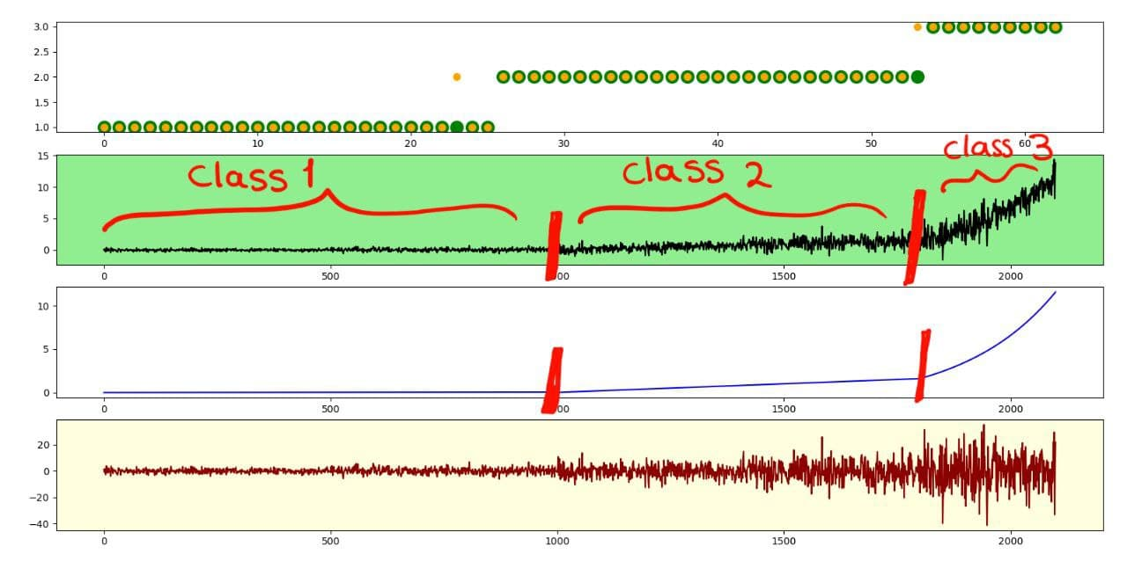

**second Step**

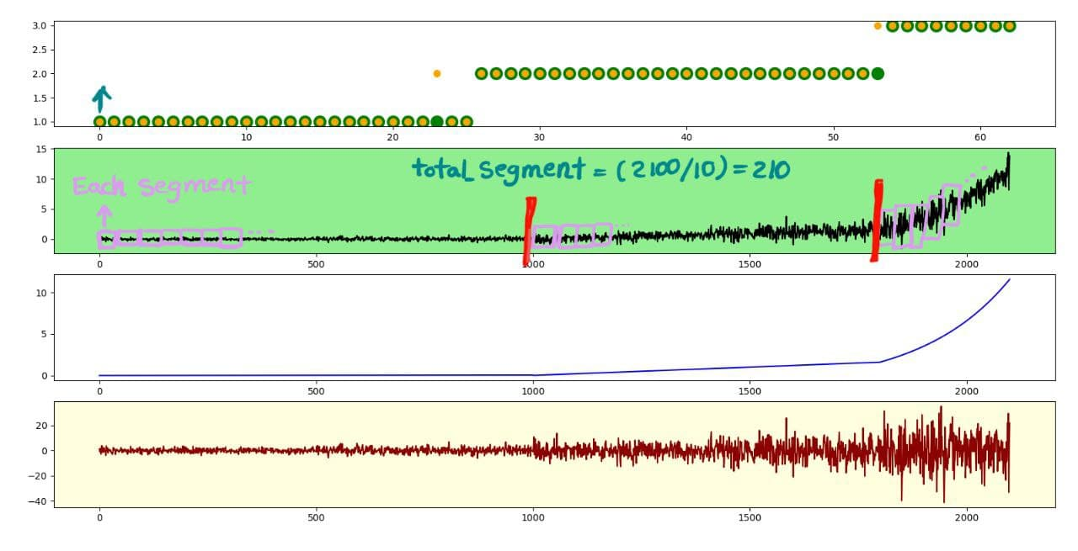

**third Step**

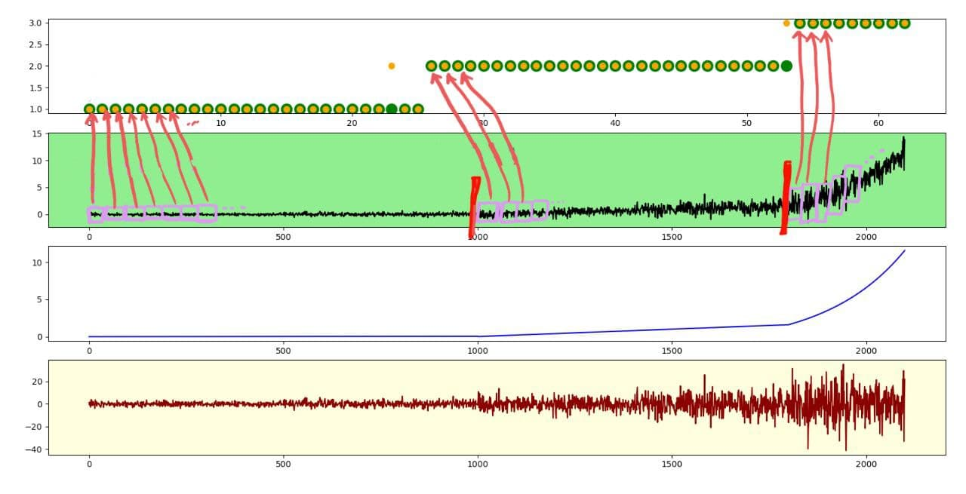

**4th Step**

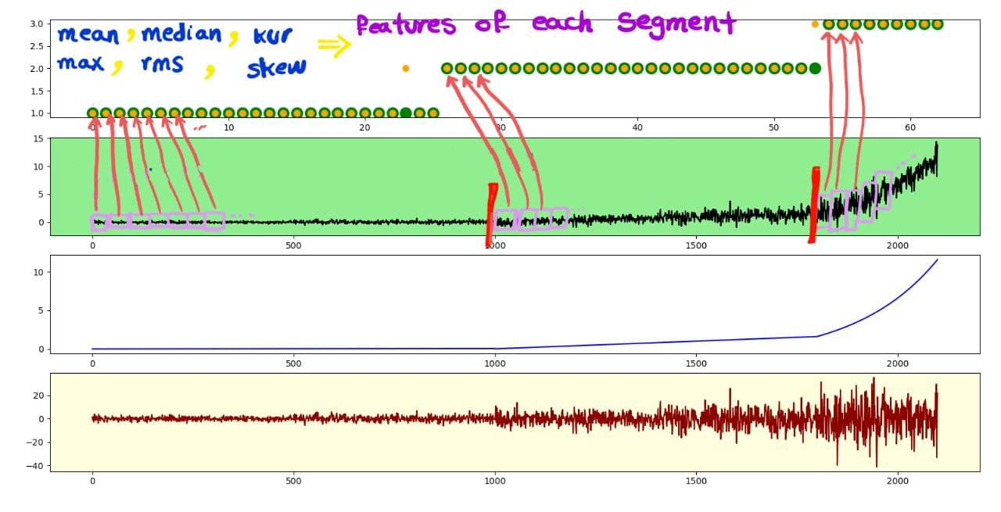

**5th Step**

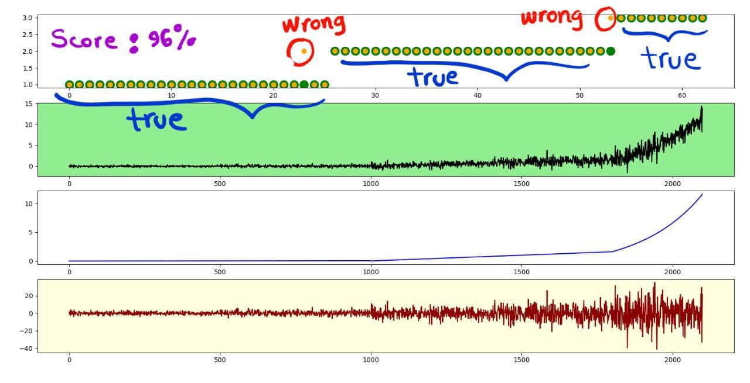

**confusion matrix**

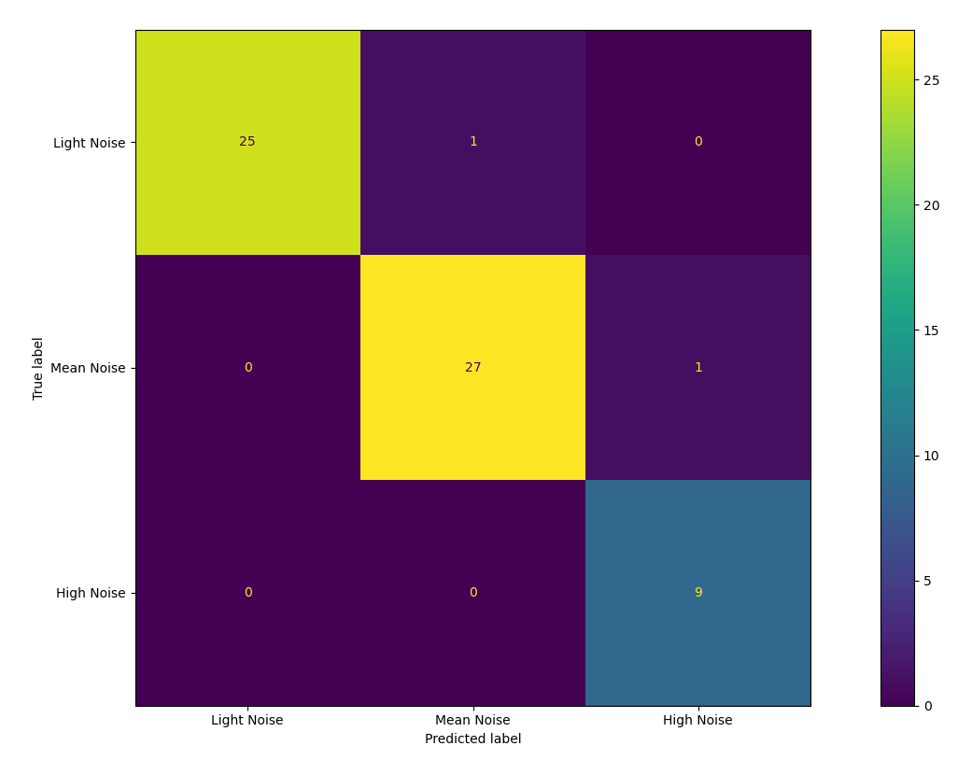

**Score: 96%**